June 2021
Preschooler program
“Our hope is in God, our strength. With Christ our head, we his people will receive the gift our wisdom and insight.

Children daily in June  In May, children were enjoying the spring weather, we spend more time in outdoor play. Children were interested about gardening. Taylor, Harsen, Jasper, Evan, Sarah, Colin, Erin, Bomi, Eden, Jihu, Laya and Logan were focused on their interest.  Teacher Grace brought a “Bleeding heart” flower from home. The children were interested in observing the heart shape flower. Laya, Harsen, Taylor and Eden tried to draw the “Bleeding heart” flower. Teachers also prepared a “Tree painting” art activity. Bomi, Colin and Jasper were interested in painting. Bomi observed the green tree and painted it details. Children noticed flowers blossom in spring season. Sarah, Laya, Harsen, Jihu, Erin and Bomi liked to pick the yellow flowers in the playground. Sometimes, they found some pink and purple flowers in the bush. Jihu would like to decorate his sand cake with flowers.  According to the children’s interests, teacher Cecilia bought some Tulips, Roses, Hydrangea, and an apple tree. And teacher let children help to plant them in playground’s garden. Children were enjoying digging the soil and planting the flowers and apple tree. Children took care the plants well. Eden, Taylor, Harsen, Jasper, Evan, Sarah and Laya were enjoying watering the flowers every day. Taylor and Jasper found ants climbing on the apple tree, they tried to get rid of the ants from the tree. Colin liked the apple tree. He kept saying “Apple tree.” Laya noticed the Tulips blooming, she said “beautiful” in Korean. She was enjoying observing the flowers, and she liked to draw flowers in the garden. |  | Parents Corner  - We have implemented new COVID-19 HEALTH AND SAFETY MEASURES.  - To reduce spreading the virus, families and visitors will not have access to the building.  - High touch areas and all toys and equipment are cleaned and sanitized daily.  - Daily health screening must be completed every morning upon arrival.  - If your child has symptoms of fever, cold, influenza and/or respiratory illness of any kind MUST NOT ENTER St. A.K. ECEC centres and MUST STAY HOME for at least 10 days from onset of symptoms or until confirmation of a negative test for COVID-19, whichever comes first.  - Please bring extra spring clothes, rain boots, jacket, sunscreen, sun hat and muddy buddies.
 |  | 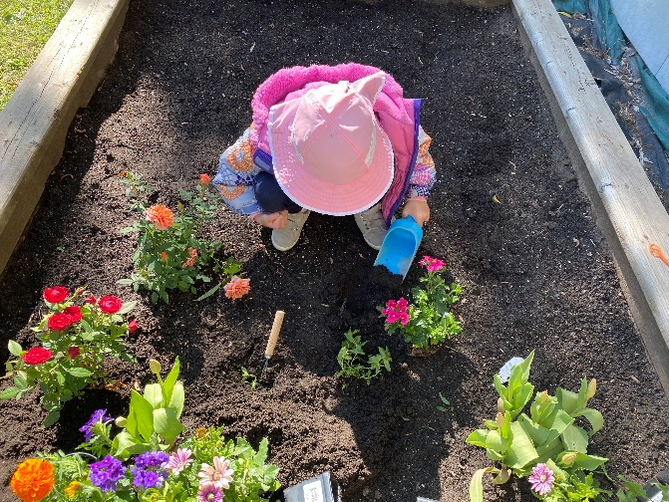
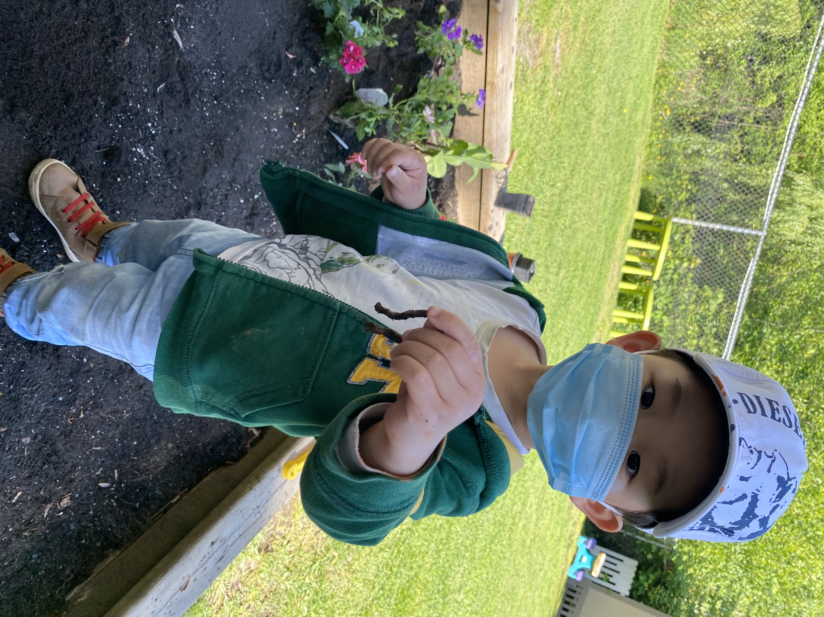 | Protect yourself and others around you by knowing the facts and taking appropriate precautions  To prevent the spread of COVID-19:  - Clean your hands often. Use soap and water, or an alcohol-based hand rub.  - Maintain a safe distance from anyone who is coughing or sneezing.  - Wear a mask when physical distancing is not possible.  - Don’t touch your eyes, nose or mouth.  - Cover your nose and mouth with your bent elbow or a tissue when you cough or sneeze.  - Stay home if you feel unwell.
www.standrewkimecec.com

